Supplementary material

Comparison of WPH at rest and post-exercise. The plasma amino acid concentrations after WPH intake at rest and post-exercise are illustrated in Supplementary Fig. 1A–D. TAA concentrations (Supplementary Fig. 1A) revealed significant time (p < 0.001) effects and interactions (p < 0.001). Post-exercise concentrations were higher than those at rest at 15 min after intake, whereas post-exercise concentrations were lower than those at rest from 60–240 min. The concentrations in EAA and BCAA (Supplementary Fig. 1B,C) revealed significant group (p < 0.003 and p < 0.001, respectively) and time (p < 0.001) effects. Additionally, EAA and BCAA levels demonstrated similar concentrations, with post-exercise levels being lower than those at rest from 60–240 min. Leucine concentrations (Supplementary Fig. 1D) had significant group (p < 0.047) and time (p < 0.001) effects, and the post-exercise level was lower than at rest after 120–240 min.
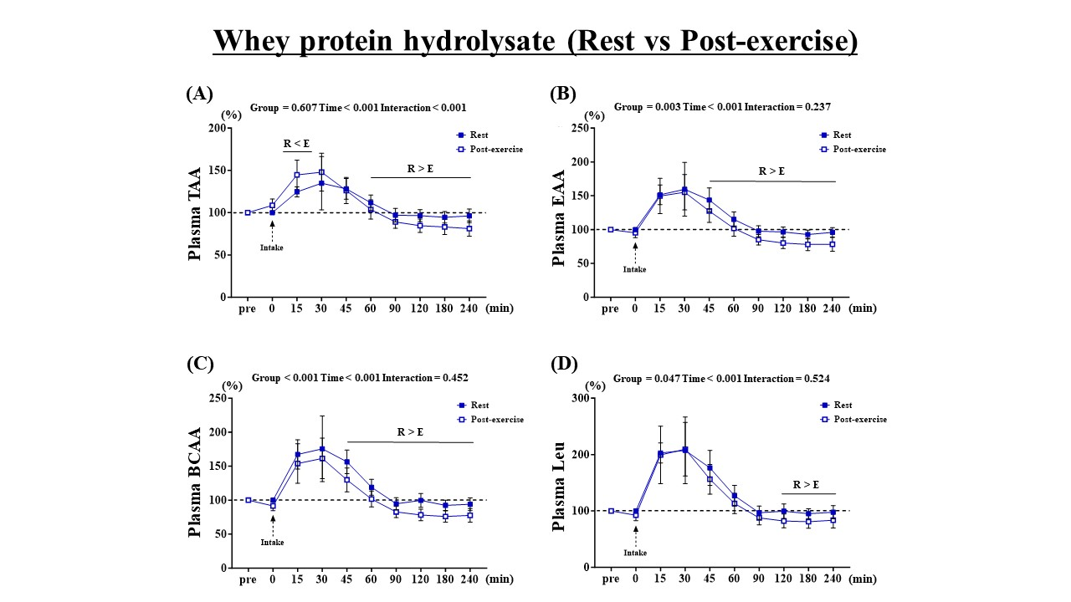
Supplementary Fig. 1. Concentrations of plasma amino acids after WPH intake at rest and post-exercise. (A) total amino acids, (B) essential amino acids, (C) branched-chain amino acids, (D) leucine. Values are presented as mean ± standard error of the mean. R < E indicates post-exercise higher than at rest (p < 0.05). R > E indicates at rest higher than post-exercise (p < 0.05). TAA: total amino acids; EAA: essential amino acids; BCAA: branched-amino acids; Leu: leucine; WPC: whey protein concentrate; WPH: whey protein hydrolysate.

